EXERCISE 3: STORED PROCEDURES
Scenario 1: Process Monthly Interest
Question:
Write a stored procedure ProcessMonthlyInterest that calculates and updates the balance of all savings accounts by applying an interest rate of 1% to the current balance.
Code
CREATE OR REPLACE PROCEDURE ProcessMonthlyInterest
IS
BEGIN
UPDATE Accounts
SET Balance = Balance + (Balance * 0.01)
WHERE AccountType = 'Savings';

COMMIT;
END;
/
Execution
EXEC ProcessMonthlyInterest;
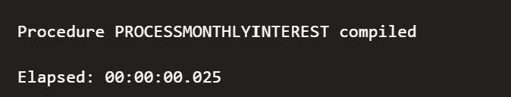
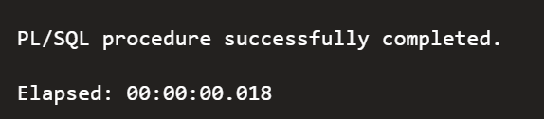
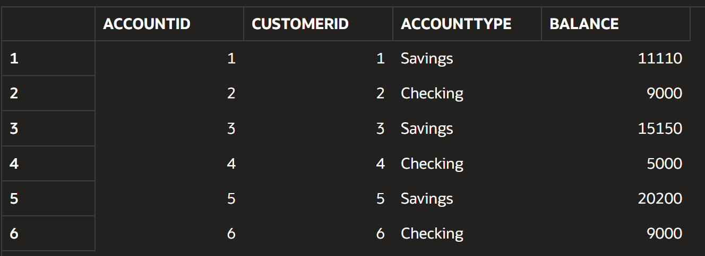

Scenario 2: Update Employee Bonus
Question:
Write a stored procedure UpdateEmployeeBonus that updates the salary of employees in a given department by adding a bonus percentage passed as a parameter.
Code
CREATE OR REPLACE PROCEDURE UpdateEmployeeBonus(
p_department VARCHAR2,
p_bonus NUMBER
)
IS
BEGIN
UPDATE Employees
SET Salary = Salary + (Salary * p_bonus / 100)
WHERE Department = p_department;

COMMIT;
END;
/
Execution
EXEC UpdateEmployeeBonus('IT',10);
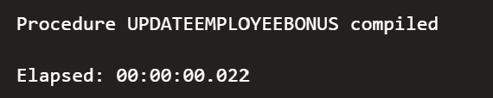
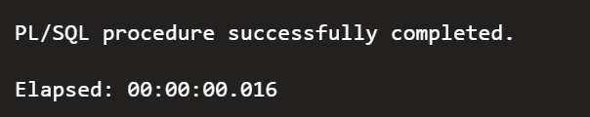
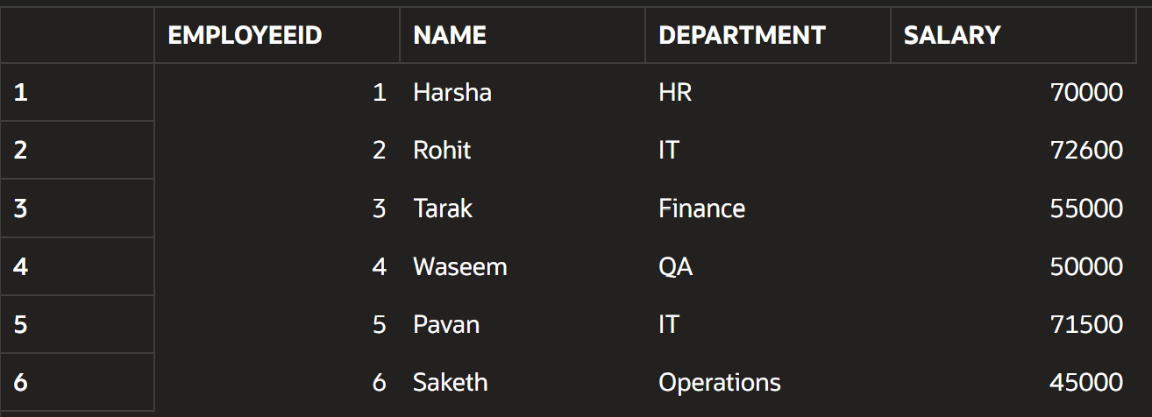

Scenario 3: Transfer Funds
Question:
Write a stored procedure TransferFunds that transfers a specified amount from one account to another, checking that the source account has sufficient balance before making the transfer.
Code
CREATE OR REPLACE PROCEDURE TransferFunds(
p_from NUMBER,
p_to NUMBER,
p_amount NUMBER
)
IS
v_balance NUMBER;
BEGIN
SELECT Balance
INTO v_balance
FROM Accounts
WHERE AccountID = p_from;

IF v_balance >= p_amount THEN

UPDATE Accounts
SET Balance = Balance - p_amount
WHERE AccountID = p_from;

UPDATE Accounts
SET Balance = Balance + p_amount
WHERE AccountID = p_to;

COMMIT;

DBMS_OUTPUT.PUT_LINE('Transfer Successful');

ELSE

DBMS_OUTPUT.PUT_LINE('Insufficient Balance');

END IF;
END;
/
Execution
EXEC TransferFunds(1,2,1000);

